**Chapter 4: x86-32 Processors**

**Topic – 1: 32-Bit x86 Processors**

**Included Processors**

* It includes **32-bit** processors of both **Intel** and **AMD**.

**Modes Of Operation**

* Protected mode
* Real-address mode
* System management mode (SMM)
* Virtual-8086 mode

**Modes Description**

* First three modes are **primary modes** & last one is **secondary mode**.

**Protected Mode**

* It is the **default state** of the processor.
* Programmer is free to use **all features** here.
* Each program runs in **separate memory spaces** called ***segments***.
* Processor avoids each program from **crossing** their **segment**.
* This ensures that any trouble in a program **doesn’t** affect other processes running at the **same time** by entering its memory space.

**Virtual-8086 mode**

* Same as **protected mode** but it has ability to run **multiple sessions** parallelly.

**Real-Address Mode**

* Provides an **early** **Intel** processor environment to write instructions.
* But with some **extra features**, like **switching** to **other modes** when within this mode.
* Now an advantage of using **old Intel** interface is that it provides **direct access** to memory & devices.

**System Management Mode (SMM)**

* Allows programmers to implement features like **power management** & **system security**.
* And these are used by **computer manufacturers**.

**Topic – 2: Basic Execution Environment**

**Address Space**

* In **protected mode**, a program can address up to **4 GB** of linear space.
* However, a technique called ***extended physical addressing*** in **P6 processor** allows up to **64 GB** of linear addressing.
* Whereas in **real-addressing mode**, a program can address only up to **1 MB** of linear space.
* So, in **virtual-8086 mode** each session can address up to **1 MB** of linear space.

**Topic – 3: Basic Program Execution Registers**

**Introduction**

* ***Registers*** are storage locations which are **faster** than **memory**.
* So, when **loops** are optimized, they are stored in **registers** instead **variables**.
* There are **8** ***general-purpose registers***, **6** ***segment registers***, a ***status flag register*** & an ***instruction pointer***.

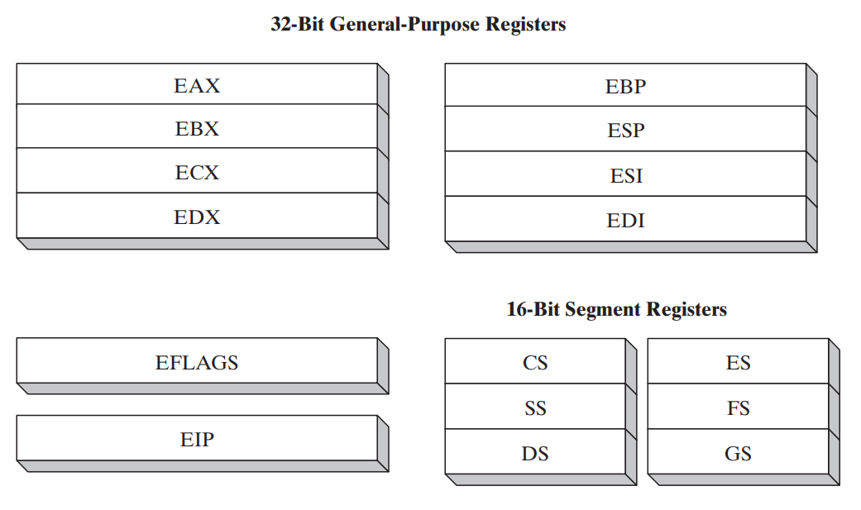

**General Purpose Registers (GPR)**

* Primarily used for **arithmetic** & **data movements**.
* The **lower** **16-bits** of **EAX** register is referenced by name **AX**.

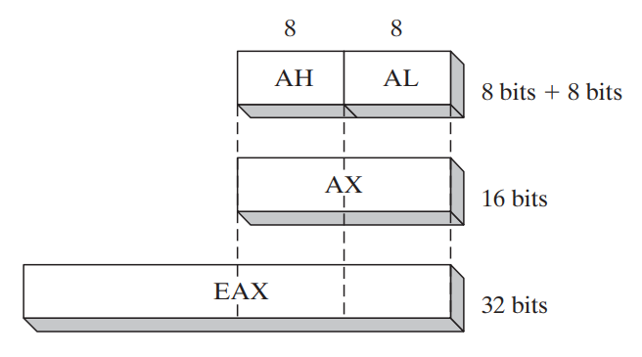

* We can access the lower & higher **8-bits** of lower **16-bits** in half of the **general-purpose registers**.
* The higher **8-bits** of **AX** is referenced as **AH** & lower **8-bits** are as **AL**.

|  |  |  |  |
| --- | --- | --- | --- |
| **32-Bit** | **16-Bit** | **8-Bit (High)** | **8-Bit (Low)** |
| **EAX** | **AX** | **AH** | **AL** |
| **EBX** | **BX** | **BH** | **BL** |

* We can access lower **16-bits** of rest half of the **general-purpose registers**.

|  |  |
| --- | --- |
| **32-Bit** | **16-Bit** |
| **ESI** | **SI** |
| **EDI** | **DI** |
| **EBP** | **BP** |
| **ESP** | **SP** |

**Topic – 4: Specialized Uses Of GPRs**

**EAX**

* Automatically used for **multiplication** & **division**.
* Also called ***extended accumulator*** register.

**ECX**

* Automatically used as a **loop counter**.

**ESP**

* Addresses data in **stack**.
* **Stack:** A type of memory structure in system.
* It is **not** used much in **arithmetic** & **data transfer** operations.
* Also called ***extended stack pointer*** register.

**ESI**

* Used in **high-speed** memory transfers.
* Also called ***extended source index*** register.

**EDI**

* It is also used in **high-speed** memory transfers.
* Also called ***extended destination index*** register.

**EBP**

* Used by **high-level** languages to reference **function parameters** & **local variables** on **stack**.
* It is advised **not** to be used in **ordinary** arithmetic & data transfers.
* Also called ***extended frame pointer*** register.

**Topic – 5: More Types Of Registers**

**Segment Register**

* ***Segment registers*** are of **16-bits**.
* In **real-addressing** mode, they hold values of real **base addresses** of some memory segments.
* In **protected mode**, they hold **pointers** to ***segment descriptor tables***.
* Some of it hold the **instructions** (code), some hold **variables** (data) & ***segment stack*** register holds local **function’s** **variables** and **parameters**.

**Instruction Pointer**

* **EIP** is ***instruction pointer*** register.
* It contains the address of **next instruction** to be executed.
* We can manipulate **EIP** through code in order to branch program at **new location**.

**EFLAGS Register**

* Contains individual **bits** that can manipulate **operations of CPU** & also tell the **nature** of some operations.
* We call flag as **set** when it is **1** & **clear** when it is **0**.

**Topic – 6: EFLAGS Register (Brief)**

**Control Flags**

* Can controls the CPU’s operations.
* Example 1: **Breaking** & **interrupting** when **out of range value** is detected.
* Example 2: Entering different modes like **virtual-8086** or **protected mode** etc.
* Flags like **direction** and **interrupt** can be set in **EFLAGS** register.

**Status Flags**

* **Carry flag (CF):** **Set** when result of an **unsigned arithmetic operation** is **too large** to fit at the destination.
* **Overflow flag (OF):** **Set** when result of a **signed arithmetic operation** is **too large** or **too small** to fit at the destination.
* **Sign flag (SF):** **Set** when result of an operation is **negative**.
* **Zero flag (ZF):** **Set** when result of an operation is **zero**.
* **Auxiliary carry (AC):** In an **8-bit** operator, it is set when an arithmetic operation generates a **carry** on the **4th bit** from **3rd bit**.
* **Parity flag (PF):** Set when ***least significant******byte*** in a result contains **even** number of **1s**.

**Topic – 7: MMX Registers**

* ***MMX*** registers are of **64-bit** each.
* **MMX** is a technology that has enhanced performance of **Intel** processors.
* They are used in **advanced multimedia** & **communication** applications.
* There are **eight MMX** registers which support special instructions called ***SIMD***.
* **SIMD:** Single-instruction, multiple-data
* **MMX** registers can operate on **multiple values** in it **parallelly**.
* Same registers are used by ***floating-point unit*** (FPU).

**Topic – 8: XMM Registers**

**Introduction**

* These are set of **eight** **128-bit** registers.
* They can be used by connecting **SIMD** extensions to the **instruction set**.

**Floating-Point Unit (FPU)**

* Does **high-speed** floating-point arithmetic.
* Earlier separate chip was required for it, but now it is attached to the main processor.
* There are **eight** registers in **FPU**, from **ST(0)** to **ST(7)**.
* Rest of them are **control** & **pointer** registers.

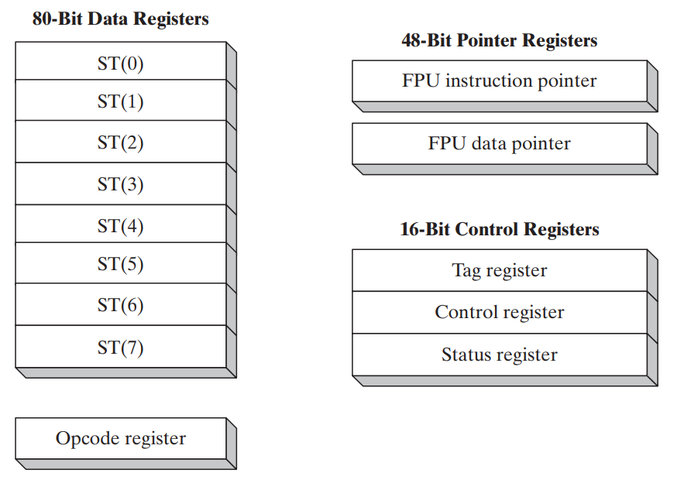

**Topic – 9: x86 Memory Management**

**Introduction**

* Processor’s way of managing memory **varies** from mode to mode.
* **Protected mode** is the **most powerful** mode & it **restricts** application programs from directly accessing hardware.
* In **real-addressing mode**, **20 MB** of memory can be addressed **(00000)16** to **(FFFFF)16**.
* And **application programs** are free to access **any** location, even those linked directly to **system hardware**.
* **MS-DOS** runs in this mode, while **Windows 95** and **98** can switch to it by **booting**.

**Nuisance Around Protected Mode**

* In **protected-mode**, programs **can’t** access each other’s **data**.
* **Modern Windows** and **Linux** run in **protected mode**.
* In **virtual-8086 mode**, **Windows NT** and **2000** had ***Command window*** which allowed users to run **virtual-8086 machine**.
* While in those OSes, some programs using **MS-DOS** **won’t** run.